L11: Preparation Assignment Worked Solutions
Name:___________________

Part I: Concepts
- List at least three characteristics of the Student's t-distribution.
- Symmetrical
- Mean of 0
- Exact shape depends on the degrees of freedom
- Bell Shaped
- More area in the tails than the standard normal distribution

- How many degrees of freedom generally does the t-distribution have when it is used for inference for a single mean?
df = n-1 (sample size – 1)

- What is the formula for the one-sample t confidence interval (confidence interval for µ when σ is unknown)?
$$(\overline{x}-t^{*} \frac{s}{\sqrt{n}} , \overline{x}+ t^{*} \frac{s}{\sqrt{n}})$$

- What are at least two differences between the one-sample t confidence interval and the one sample z confidence interval we covered in Lesson 10?
- Sigma is not known
- We compute a t-score from the Student T-distribution rather than a z-score from the normal distribution. (We cannot use the Normal Applet to compute t-scores.)
- We must now consider degrees of freedom for the t-distribution where the normal distribution did not have degrees of freedom.
- When conducting a hypotheses test for a single mean with sigma unknown, what is formula used to compute the sample test statistic?
$$t= \frac{\overline{x}- μ}{\frac{s}{√n}}$$

- What are the assumptions that need to be met to conduct a hypotheses test for a single mean when sigma is unknown?
- A simple random sample was drawn from a population.
- $\overline{x}$ Is normally distributed.

Part II : Application
A study by the National Association of Realtors reported in 2004 that second-home sales accounted for more than a third of residential real estate transactions. According to the report, the average age of a person buying a second home as an investment rental property was 47 years. A real estate agent wants to estimate the average age of those buying investment properties in his area. He randomly selects 15 of his clients who purchased an investment property and obtains the data shown.
27 | 49 | 56 | 45 | 49
35 | 55 | 50 | 46 | 48
38 | 58 | 51 | 56 | 38

- What are the requirements for creating a 95% confidence t-interval?
- It is a random sample from a population.
- The $\overline{x}$ ‘s are normally distributed
- Using your calculator or Excel, compute the sample mean and sample standard deviation for the 15 pieces of data you see in Part II.
(This is the same data that we used in the last lesson’s preparation assignment)
Sample mean = 46.73
Sample standard deviation = 8.83

- With the data above, create a 95% confidence interval to estimate the mean age of all clients who buy an investment property. Input the numbers you computed in the previous problem into the confidence interval formula. Show your work below. The t-score for a 95% confidence interval from the t-distribution with 14 degrees of freedom is 2.1448. Round your upper and lower bound to one decimal place, but do not do this rounding until you have done all your computations.
$$\left(\overline{x}-t^{*} \frac{s}{\sqrt{n}} , \overline{x}+ t^{*} \frac{s}{\sqrt{n}}\right)$$
$$\left(46.73-2.1448*\frac{8.83}{\sqrt{15}}, 46.73+2.1448*\frac{8.83}{\sqrt{15}}\right)$$
(41.8, 51.6)

- Now create a 99% confidence interval to estimate the mean age of all the clients who built an investment property. Follow the same rounding rules as above. The t-score for a 99% confidence interval from the t-distribution with 14 degrees of freedom is 2.9768.
$$\left(\overline{x}-t^{*} \frac{s}{\sqrt{n}} , \overline{x}+ t^{*} \frac{s}{\sqrt{n}}\right)$$
$$\left(46.73-2.9768*\frac{8.83}{\sqrt{15}}, 46.73+2.9768*\frac{8.83}{\sqrt{15}}\right)$$
(39.9, 53.5)

- Now using software compute:
a. The 95% confidence interval using the data above.
(41.8, 51.6)
This is done by using the Excel Spreadsheet “Quantitative Descriptive Statistics”. Under the One Sample T-test tab enter in the data where it says “Variable 1” in column A of the spreadsheet. Then make sure you enter in 0.95 in the confidence level box, which is located in cell D9. The confidence interval is then found below where it says “Confidence Interval”. This is all shown in following screen shot.
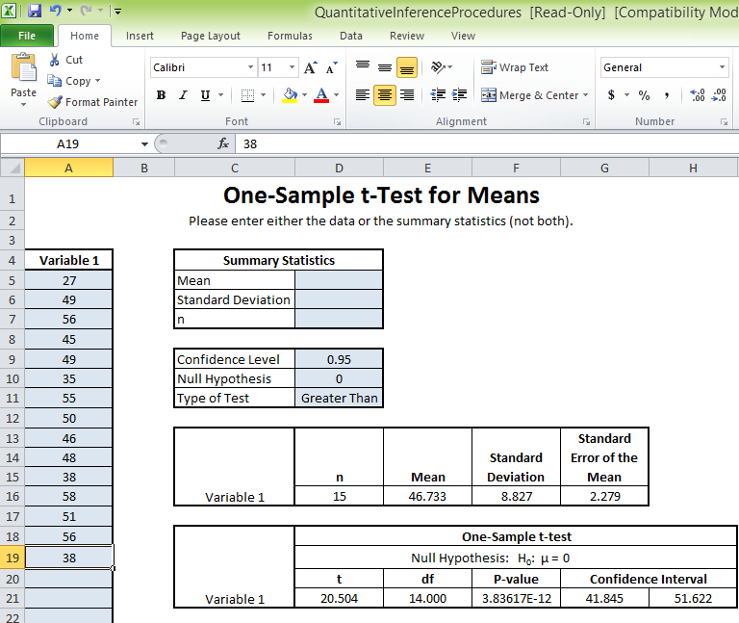
Data (type in)
Confidence Interval (given)
Confidence Level (type in)

b. The 99% confidence interval using the data above.
(39.9, 53.5)
This is done the same way as the problem above only changing the confidence level to 0.99.

- How does the margin of error of the 95% confidence interval compare to the 99% interval?
The margin of error for the confidence interval is smaller for a 95% confidence level than a 99% confidence level.

- Rather than estimating the age of his clients that buy investment properties, the realtor agent would like to test the claim that the age of his clients is different than the national average of age 47. Use the 0.05 as your level of significance. Follow the following sequence of steps. Fill in your answers at each step and show all your work.

  - State the Null and Alternative Hypothesis
$$H_{o}: μ=47$$
$$H_{a}: μ ≠47$$
This is a two tailed test. You can look back at the researchers question to make this decision. It says, “a real estate agent wants to determine if the average age of those buying investment property in his area is different than the national average.” The key words here are different than.

  - Compute the test statistic. First compute it using the formula and showing your work below. Then check this test statistic by inputting the data into the software.
$$t= \frac{\overline{x}- μ}{\frac{s}{√n}}$$
$$t=\frac{46.73-47}{\frac{8.83}{√15}}= -0.118$$
$$t = -0.117$$
  - State the Degrees of Freedom: df = n-1 = 15-1 = 14
  - Sketch the t-distribution and shade the area which represents the P-value.
(Students should have sketched a t-distribution and shaded the tales.)
Although we can no longer use the normal probability applet to compute the p-value we can use it to sketch a distribution, as is shown below.
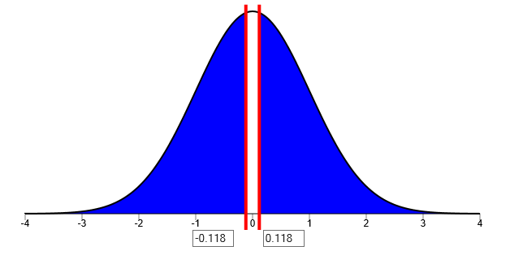

  - Use your Software to compute the P-value.

P-value = 0.909
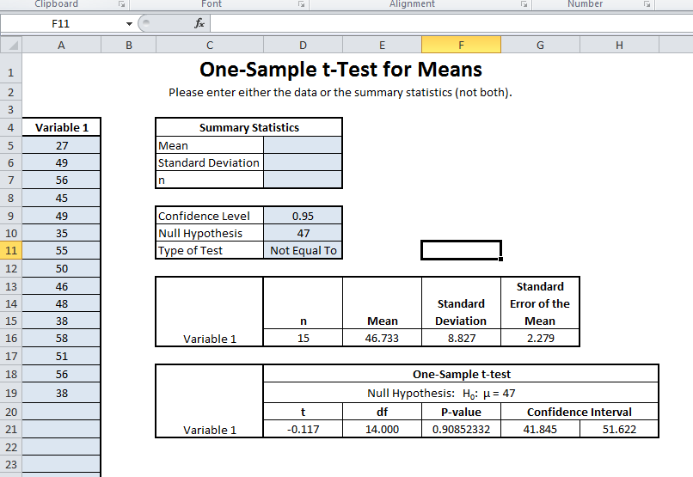
This is found by using the excel tool, “Quantitative Descriptive Statistics”. Type in the data that is found in the table above in the same way that you did to find the confidence intervals. Then enter in the null hypothesis, which in this case is 47 in the cell labeled null hypothesis. Change the type of test to “Not Equal to”. The correct test statistic and p-value should be located below in the cells labeled, “t” and “p-value”. This is all shown in a screen shot below.
P-value (given)
Null hypothesis and type of test (type in)

  - State your decision. Do you reject the null hypothesis or fail to reject at the .05 level of significance?
Fail to reject the null hypothesis. 0.9085 > 0.05

  - Present your conclusion in an English sentence, relating the result to the context of the problem.
We have insufficient evidence to conclude that the mean age of this realtors customers who are buying second homes, is different than the natural average.

